**Day 1-2: 1/12/2023 -2/12/2023**

* Create Repository github and Invide teammate (*Phát*)

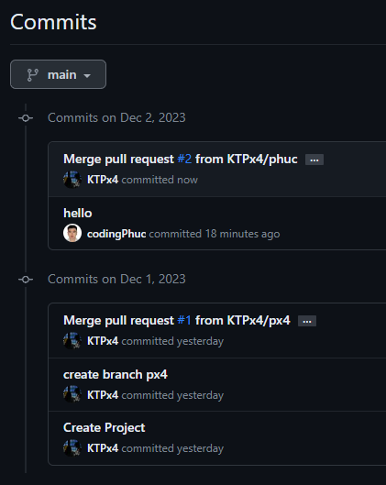

* Plan idea for project and analysis requirement (Phát + Phúc):

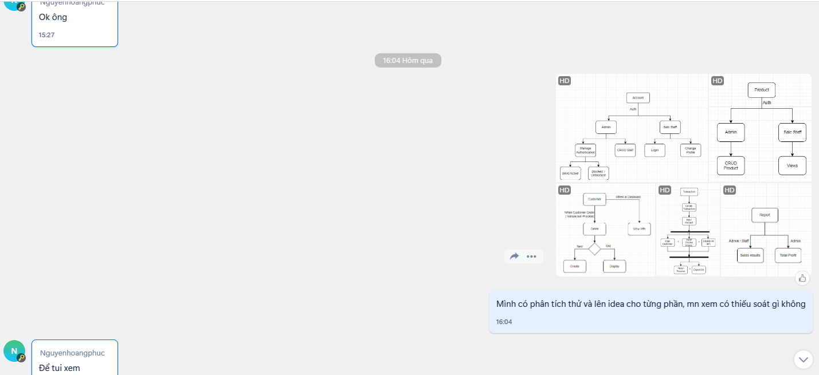

**Day 3-7: 3->7/12/2023**

* Analysis Requirement: Define Functional and Non-Functional for website (*Phát + Phúc*)

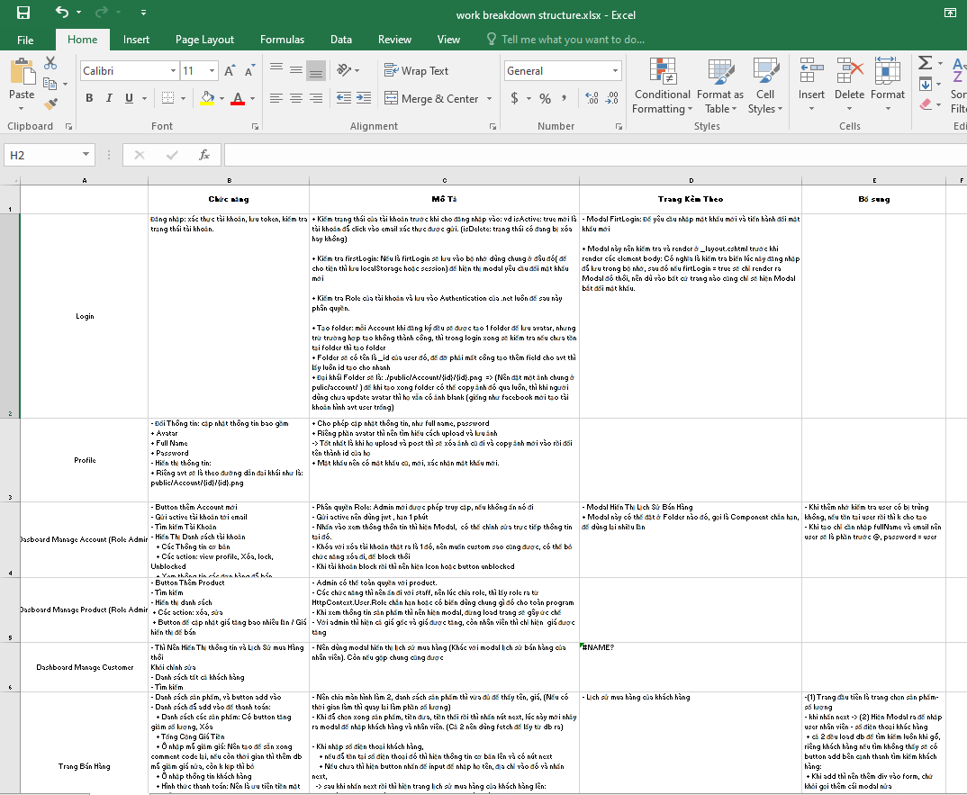

* Creating Blank Project (*Phúc)*

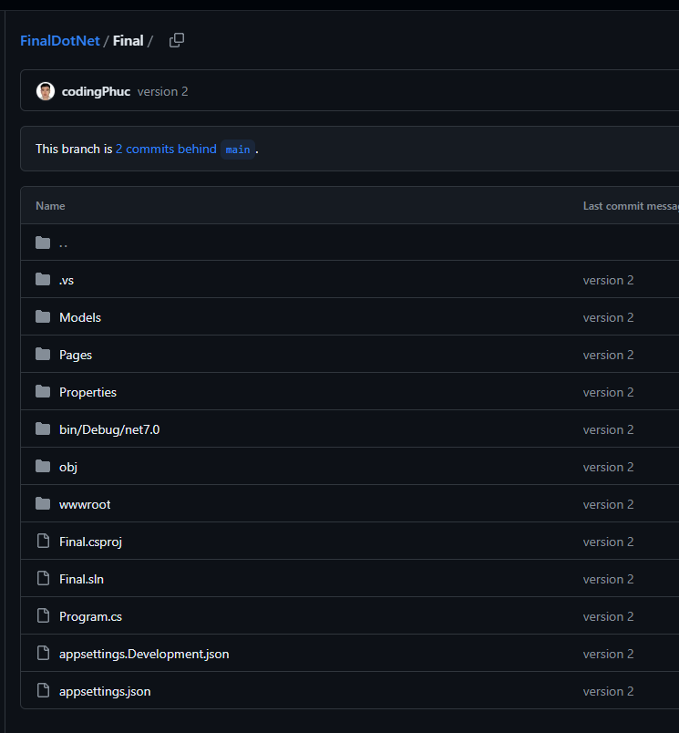

* Testing Connect to MongoDB (Phát + Phúc)

Create DataContext , Model, Test Database



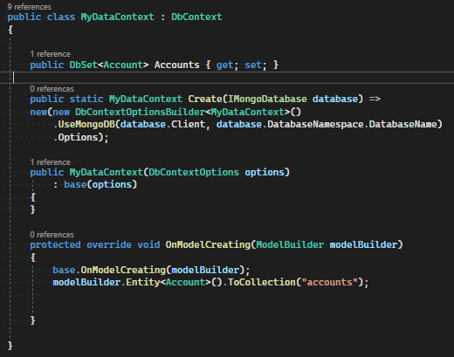

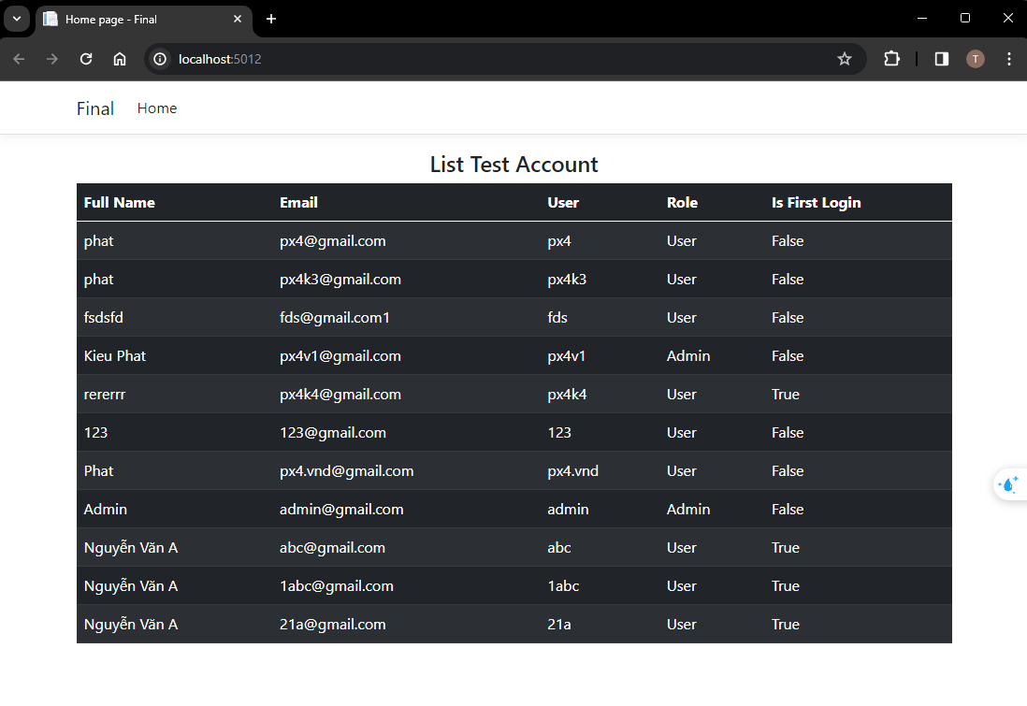

Day 8: 8/12/2023:

* Invite Phuc join to Shared MongoDB Alat

